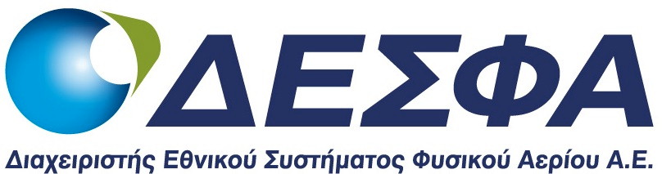
Inquiry No 728/17/ddp

“Supply of Natural Gas Quantity required for the Operational Gas Offsetting in the Hellenic Natural Gas Transmission System during the Year 2018”

Application Due Date Extension

We hereby announce the extension of the Application Due Date for submission of Tenders for the Inquiry No 728/17/DDP

NEW APPLICATION DUE DATE: 25.08.2017 at 12:00 a.m.
NEW DATE FOR THE OPENING PROCEDURE: 25.08.2017 at 12:30 p.m.
The Tender Documents shall be available to the Bidders, in physical and electronic form until 16.08.2017 and can be either purchased in hard-copy by a duly authorized Bidder’s representative or downloaded electronically from the internet address WWW.DESFA.GR (ANNOUNCEMENTS - ARCHIVE OF TENDER DOCUMENTS, MENU ITEM: TENDER DOCUMENTS).

All the other terms and conditions of the Inquiry No 728/17/DDP remain unchanged.

